A statistical analysis of cancer factors
Introduction
Cancer is one of the most deadly diseases of this century, a status that is reinforced by the fact that major research laboratories are struggling to find a cure or an effective vaccine to counter it. In this regard, treatments exist but are for the most part very uncomfortable for the patient. Because the vast majority of available treatments have side effects such as hair loss, permanent fatigue, etc... but in addition to that do not offer a guarantee of total cure. Some patients prefer to do without these treatments. This makes the best way to fight against cancer at this moment prevention. And a good prevention requires a good knowledge of the factors of incidence on cancer.

Statement of Questions
This research project evaluates the factors that influence the incident of cancer. To do so, the study asks two specific questions. The first is whether there is a relationship between gender and incidence. The second is whether there is an age-related effect on incidence.

Description of Data
This study was conducted on 2106 individuals among these people, there are 1062 men and 1044 women. this distribution can be visualized in the following figure.
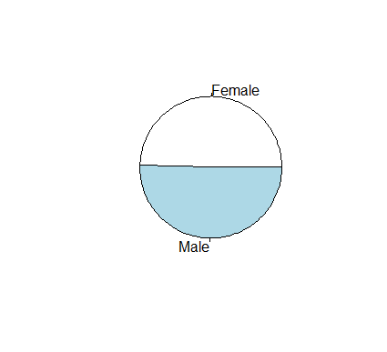
Fig 1: Gender distribution
The age is distributed according to the age groups as follows:
- 0-14: 378
- 15-39: 432
- 40-64: 432
- 65-74: 432
- 75+: 432
which is summarized in the following figure (fig 2)
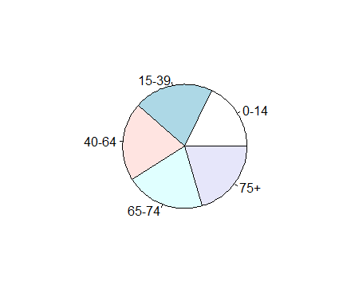
Fig 2: Age distribution
Statistical Tests and Basic Assumptions
Since the dependent variable (Incidence) is a quantitative variable and the independent variable (Sex) is qualitative, we choose ANOVA was performed to determine if there is a relationship between incidence and sex. For this, we tested without success the hypothesis of normality of the dependent variable (p-value < 2.2e-16). Then we performed the Bartlett test to check the homogeneity of variance between the groups of women and men. This test also failed (p-value < 2.2e-16). Hence, we should no longer use an ANOVA so as not to have a biased inference. Although tests for normality of the dependent variable and homogeneity of variance failed, we will continue the analyses. Furthermore, we choose an alpha level of 0.05.
To determine if there is an age-related effect on incidence, we also choose ANOVA (dependent variable is a quantitative variable and the independent variable is qualitative), especially since there are more than two groups in this case. For this, we tested without success the hypothesis of normality of the dependent variable (p-value < 2.2e-16). The Bartlett test between the Incidence and Age variables was unsuccessfully performed (p-value < 2.2e-16). So we should not also use an ANOVA in order to avoid biased inferences. Although the tests of normality and homogeneity of variances have failed, we continue the analyses. Furthermore, we choose an alpha level of 0.05.
Results and Analysis
To test if there is a relationship between incidence and sex, I consider the following hypotheses: H0: mu_{F} = mu_{M} and Ha: mu_{F}$≠$mu_{M}. Running the ANOVA yields a p-value of 2.69e-16. We conduct a TukeyHSD test because ANOVA was significant.
 | diff | lwr | upr | p adj
Male-Female | 343.72 | 262.0469 | 425.3931 | 0
 | diff | lwr | upr | p adj
[15-39]-[0-14] | 47.37684 | -28.90582 | 123.6595 | 0.4368366
[40-64]-[0-14] | 483.91482 | 407.63216 | 560.1975 | 0.0
[65-74]-[0-14] | 1695.18829 | 1618.90564 | 1771.4709 | 0.0
[75+]-[0-14] | 2158.81375 | 2082.53109 | 2235.0964 | 0.0
[40-64]-[15-39] | 436.53798 | 362.84193 | 510.2340 | 0.0
[65-74]-[15-39] | 1647.81145 | 1574.11541 | 1721.5075 | 0.0
[75+]-[15-39] | 2111.43691 | 2037.74086 | 2185.1330 | 0.0
[65-74]-[40-64] | 1211.27347 | 1137.57742 | 1284.9695 | 0.0
[75+]-[40-64] | 1674.89893 | 1601.20288 | 1748.5950 | 0.0
[75+]-[65-74] | 463.62546 | 389.92941 | 537.3215 | 0.0
With an alpha of 0.05 and p-value of 2.69e-16, we reject the null and state that we have sufficient evidence to support that sex has an effect on Incidence. Hence, there is a relationship between incidence and sex. To answer the second research question, we consider these hypotheses: H0: all means are equal and Ha: at least one mean is different. Running the ANOVA yields a p-value <2e-16. We conduct a TukeyHSD test because ANOVA was significant.
Table 2: TukeyHSD report
With an alpha of 0.05 and p-value <2e-16, we reject the null and state that we have sufficient evidence to support that at least one mean is different. Therefore, there is an age-related effect on incidence.

Conclusion
Cancer is a very dangerous disease so understanding these incidence factors is a must for better prevention. The ANOVA allowed us to state with a high level of certainty that gender and age are factors that greatly influence cancer incidence. However, it should be kept in mind that these results were obtained when the tests of normality and homogeneity were not respected. It is therefore possible that these results are biased. The levels of certainty being very high, we would know from the choice of the results obtained according to the choice of alpha because the conclusions drawn would be the same even if we took a rather low value of alpha.

